**QLessCards.XML Table**

0. Id - Auto Incremental

1. SerialNo - Card Serial Number

2. DatePurchase - Implement date picker

3. CardType - Regular;Discounted

6. DiscountedCount - None,Senior, PWD

**Below are TODOs not yet implemented subject for modification**

***QLESSTransCardReloading Table***

0. Id - Auto Incremental

1. QLessCardId

2. TransDate

3. LoadMethod - (Direct Cash; Mobile Credit; Bank Transfer Transaction)

4. AmtLoaded

5. ChargesAmt

6. OTPcode

7. BankVerCode

***TrantractionEntry Table***

0. Id - Auto Incremental

1. QLessCardId

2. EntryPoint

3. ExitPoint

4. MatrixFare

5. DiscountAmt

6. DebitedAmt

Pre requisite Skills

**JQuery, ASP.NET MVC, C#, Ajax, XML**

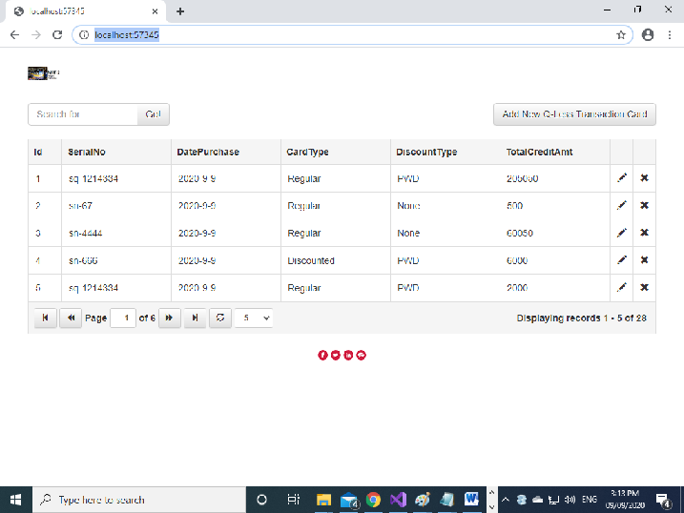

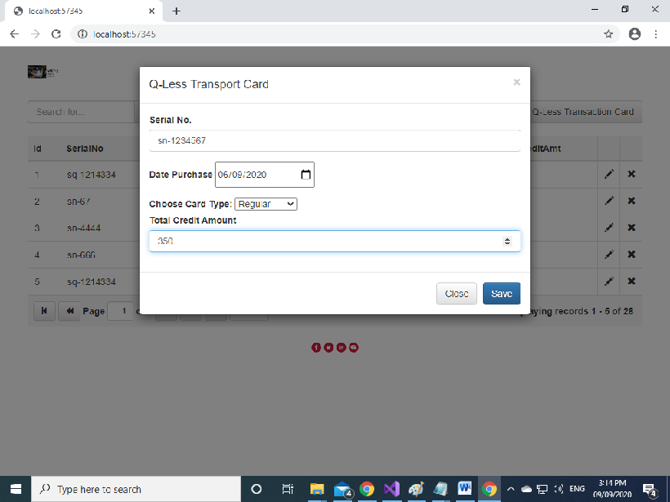

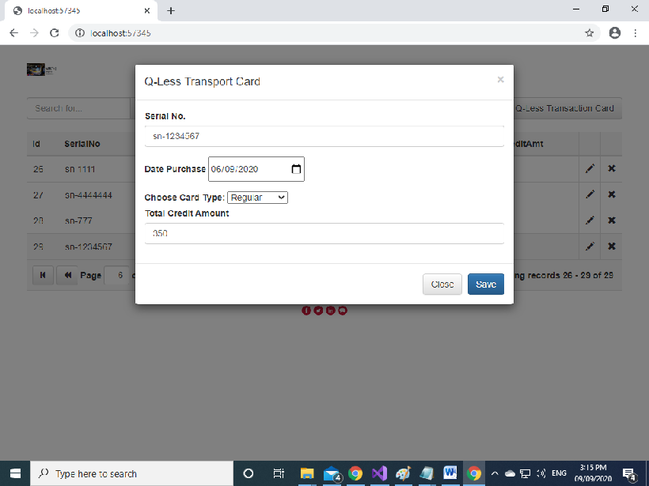

**Records are save in QLessCards.XML file located at**

**C:\Users\al\Downloads\Magenic\MRT2\Algem Mojedo-Sample\App_Data**

I did not have time to finish this sample exam. I just want to show how I implemented it. If you have any question regarding my coding, Please do not hesitate to contact me @ cell no. **09278484737**

Thanks and regards,

Algem Mojedo